**Experiment 5.1 Voltage Follower**

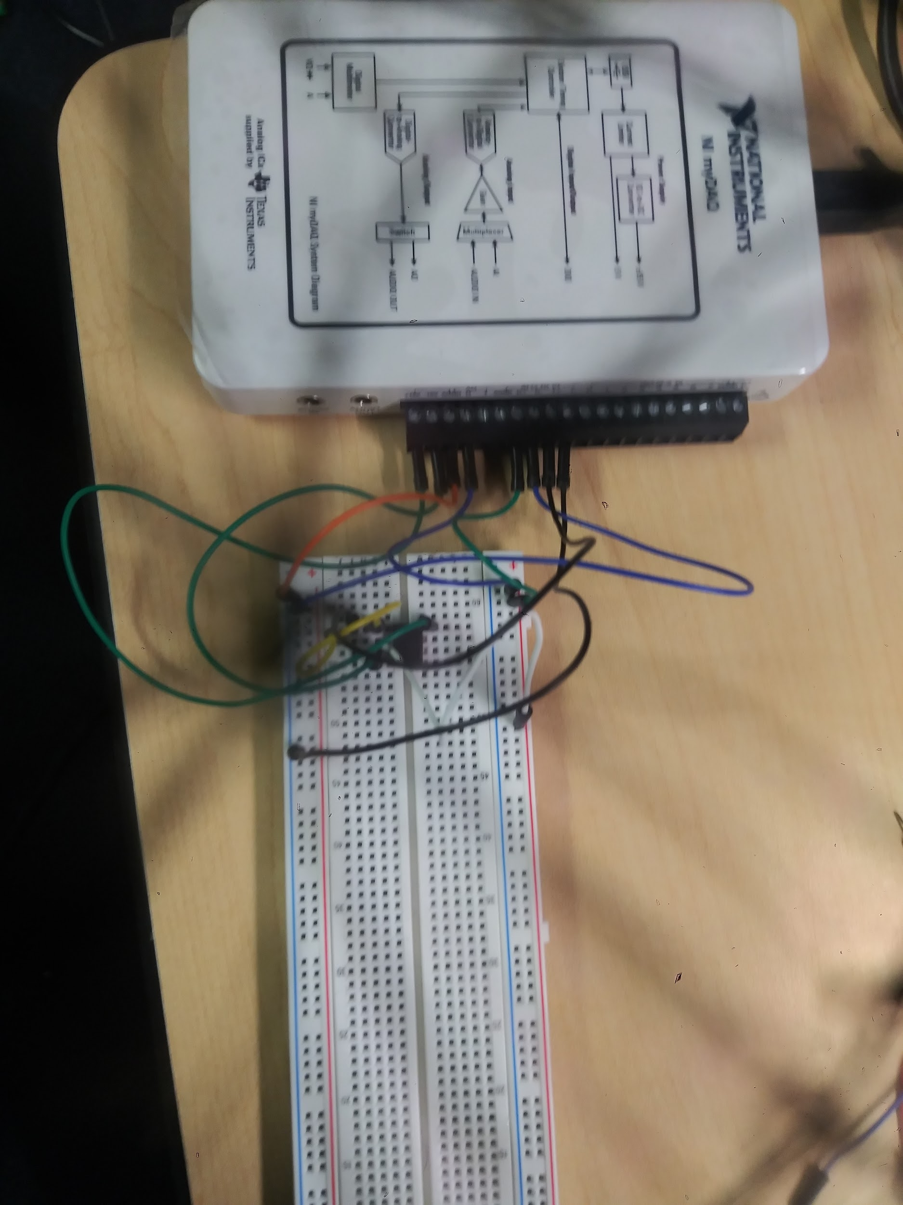

1. Output voltage 100.64mV input voltage was 100.50mV
2. The gain is Vout / Vin . ~ 1
3. The wave-forms are more or less identical sinusoids
4. Takes in signal
5. To feed output signal back in
6. This is to prevent signal inversion. Unity gain is achieved by negative feedback according to allaboutcircuits.com

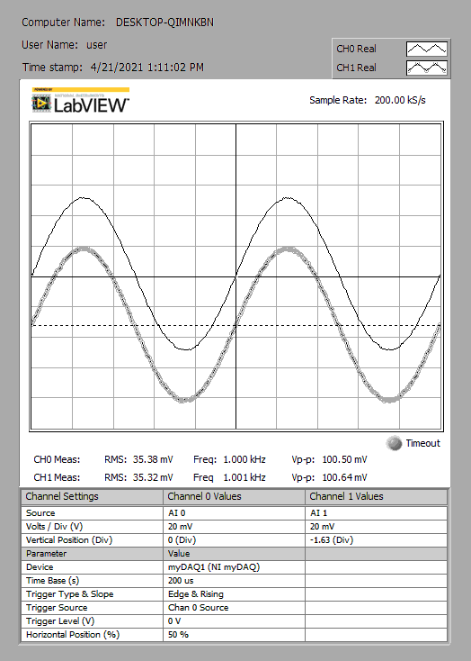

**Experiment 5.2 Non-Inverting Amplifier**

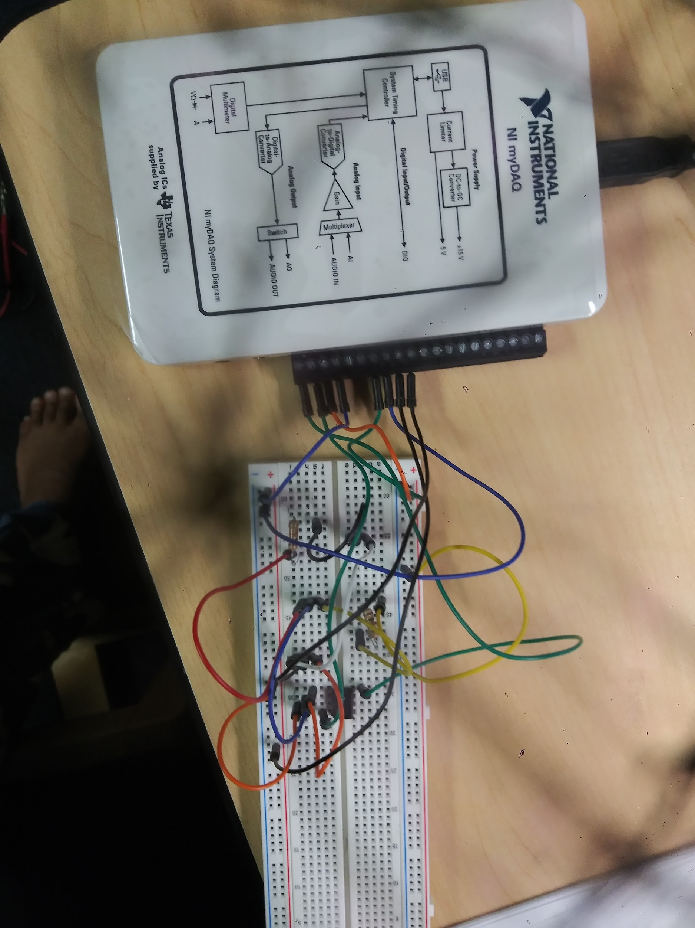

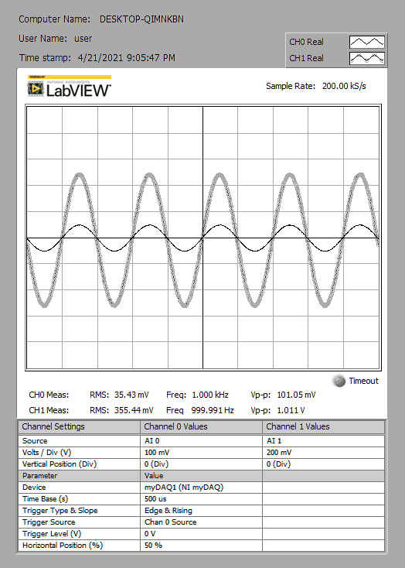

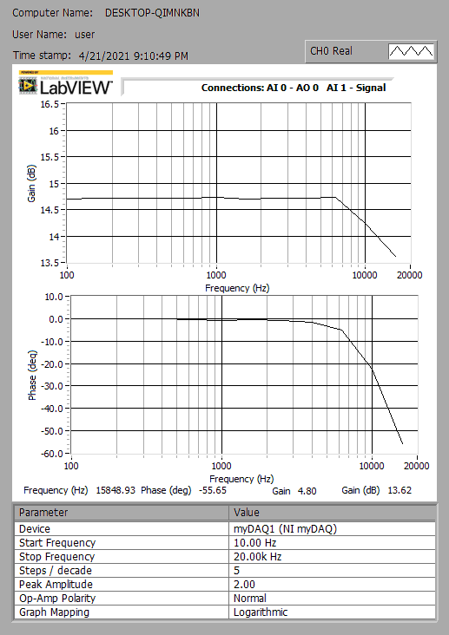

**Experiment 5.3 Operational Amplifier Integrator**

